**Volumetric 3D Display Module Requirements**

**Background:**

The physical world around us is three-dimensional (3D), yet traditional display devices can show only two-dimensional (2D) flat images that lack depth (the third dimension) information. This fundamental restriction greatly limits our ability to perceive and to understand the complexity of real-world objects. If a 2D picture is worth a thousand words, then a 3D image is worth a million.

Volumetric displays have been used in medical imaging, advertising, simulation, video gaming and more. The ability to project a 3D image is possible by taking advantage of the human persistence of vision. An example of this for this project would be spinning LEDs at a minimum of 1800 revolutions per minute, such that the human eye cannot comprehend individual LEDs at a single point. When we combine this effect with the precise control of on/off patterning of the LEDs we create an illusion of a fixed image being formed.

**Concept of Operation:**

A volumetric 3D display module is a spinning array of LEDs that will project a 3D image that appears to be floating in the air. This will be done by taking advantage of the persistence of vision effect mentioned earlier in this document.

By precisely controlling the LED’s on/off state, a 3D image can be produced. However, there are some challenges. This method faces a major challenge in the communication bandwidth as the size of a 3D image is cubically proportional to the length of its side. Hence, the exponential increase in bandwidth requirements precludes raw voxel image transfer from being a viable method. At the same time, the entire burden of 3D image generation is placed on the host PC.  
 Daybreak Ventures, LLC, who is stakeholder of this project is being represented by our Sponsor, Ken Vaughn, who is commissioning us to do this project to integrate this as a subsystem suitable for integration into a gaming application. The user of this 3D module will transfer a 3D image file to the module via USB, sd card, or wireless method, and then when the module is turned on it will create the POV image through the spinning of LEDs. This module can display a different image when the user inputs a new image file.

**Stakeholder:**

* DayBreak Ventures, LLC
  + Ken Vaughn (Sponsor)
* Project Team
  + Arturo Espino
  + Zheliang Zhang
  + Shiyu Li
  + Sean Schorzman

**Objective**

Design a low cost, fairly flat designed 3D display module that will be used as a subsystem suitable for the integration into gaming applications.

**Product Design:**

*Needs:*

* Low-Cost: Less than or equal to $150/module
* 3D display module (2x)
* Portable:
  + Flat - Less than 3 inches in height
  + Circular with a diameter of less than 7 inches
* Project a single image of a 3D object about no less than 2” in diameter
* Uses a motor to spin the linear array of LEDs at no less than 1800 rpm to induce “persistence of vision” effect
* Easy 3D image transferring interface - sd card, wireless, or USB
* High LED quality for bright environments
* On/off control via incorporation of motion sensor control to turn off the display via “waving” above the module
* Safe and easy to use (ie: no sharp edges)

**Design Specifications:**

* LEDs -
  + APA102 2020 - Smart RGB LEDs
* Ring Motor ((TBD) -
  + Bigger than 2” inner diameter
* Gesture Sensor -
  + VCNL4020-GS08
* Arduino IDE
* ESC 30A: control the speed of the motor
* Processor: Atmega328p
* Potentiometer
* Power: Wall outlet (120V AC)

**Competition:**

Alternatives include bulkier LED fans. We are creating essentially the same thing, but on a smaller scale. Our product will be flatter and cheaper, because we found that similar products are very expensive (from $150 to $1,200) and very huge (16.5 inches, 25.6 inches, and 32.5 inches) on Amazon. At the same time, two advantages of our products are owning NFC and gesture controlling.

**Block Diagram:**

Level 0:

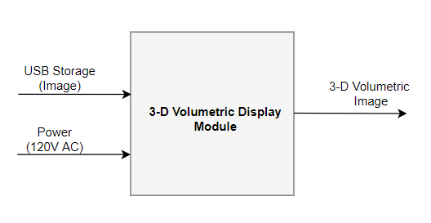

Level 1:

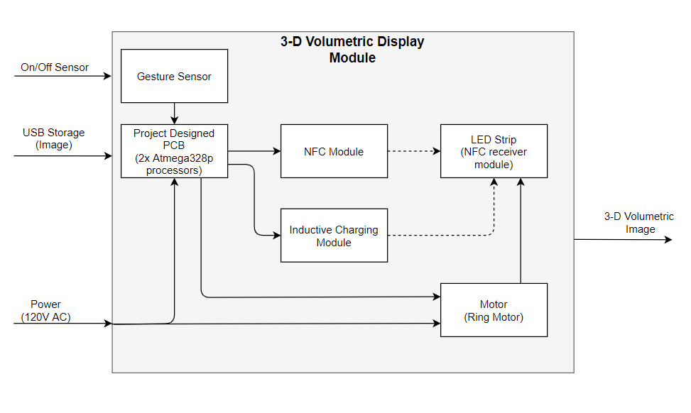

**Budget/Resources:**

|  |  |  |
| --- | --- | --- |
| **Part** | **Price** | **URL Link** |
| LEDS APA102C 5050 RGB | $36.00 | https://amzn.to/3781b70 |
| (Alternative) LEDs 2020 APA102 | $30.00 | https://www.adafruit.com/product/3587 |
| Microcontroller (2x) | $4.02 | https://bit.ly/3bkvyub |
| Strip matrix PCB | $7.00 | https://amzn.to/3bnsT2X |
| Voltage Regulator (5V) | $0.44 | https://bit.ly/378kE7u |
| Gesture Control | $3.18 | https://bit.ly/3bk0afx |
| Motor | TBD | N/A |
| PCB Manufacture | ~$40.00 | https://docs.oshpark.com/services/two-layer/ |

* Sponsor is willing to purchase POV LED fan for the team to reverse engineer product
* Resources include:
  + EPL Lab (Reflow Oven and Parts)
  + Techtronix and Capstone Lab (Build and Soldering)
  + Personal Lockers (Storage)
  + Online Suppliers (Digikey, Adafruit, Amazon)

**Deliverables:**

* Project Proposal
* Weekly Progress Reports
  + Individual Report
  + Project Team Report
* Final Report
* 3D Volumetric Display Modules (2x)
* ECE Capstone Poster Session
* All Documentation (Github)
  + Bill of Materials
  + Schematics and Board Layouts (Eagle CAD)

**Initial Product Design:**

* Hardware Architecture
  + See Block Diagrams (L0 and L1)
* Software Architecture
  + Arduino IDE
  + EAGLE CAD
* User Interface
  + TBD

**Verification Plans:**

We will verify that our projects work with video proof and a checklist determined by our ‘Needs/Must’ section described above.

We will include simple test plans that will test:

* Gesture Sensor
* Data Transfer
* Motor Start-up
* LED (On/Off)

**TimeLine:**



